LivePhoto Physics Activity 1 Name: Date:
Rolling Ball

Imagine a pool ball rolling briskly along on a flat, level track for a distance of less than a meter. Your goal in this activity is (1) to predict what a graph of the ball’s position vs. time (or x vs. t) will look like and (2) to use Logger Pro software to analyze a digital video clip of a rolling ball to test your prediction and find the speed of the ball as a function of time.

Preliminary Questions

Note: You will receive full credit for each prediction made in this preliminary section whether or not it matches conclusions you reach in the next section. As part of the learning process it is important to compare your predictions with your results. Do not change your predictions!
- Imagine a ball rolling briskly along on a flat, level surface for a distance of less than a meter. How would it move? Would you expect to see it speeding up, moving at a constant speed, or slowing down? Explain your reasoning.

The ball would be slowing down. This is because of the friction acting against the ball on the track.

- If you were to play a movie of the ball rolling on a level table and/or replay it on a frame-by-frame basis, how could you test your prediction about its motion? Explain.

I would measure the distance the ball travels in each frame. As the frame progresses, the distance travelled by the ball would decrease which would indicate a decrease in velocity.

- Sketch graphs of the location of a ball along an x-axis when it is speeding up, moving at a constant velocity, and slowing down. Assume timing starts when the ball’s leading edge is at the origin.

Speeding Up
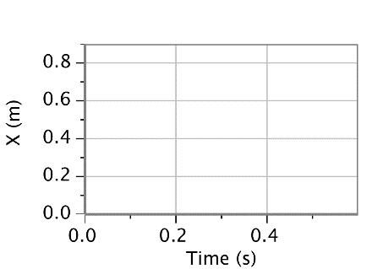
Constant Velocity
Slowing Down

Physics with Video Analysis 1 - 1

Activity-Based Questions
- Open the file <Galileo'sProjectile _Pt1.mov> in QuickTime Player. Play the movie or advance it
frame-by-frame using the right arrow key ( ) on your keyboard. Can you tell whether it is speeding
up, slowing down or moving at a constant s7peed? If so explain how you know.

The ball is moving at a constant speed because on each frame it moves the same distance. However, we believe it is slowing down due to friction acting on it.

- Open the Logger Pro experiment file <RollingBall.cmbl> to open a video analysis file with the rolling ball movie inserted. Click the Add Point tool ) near the top right side of the movie window. Then click on the front of the ball in each frame to record the position in picture elements or pixels for short. Note: If you mess up, just close and re-open the movie and start over. (You’ll learn how to fix bad point markers later on.)
What does the graph’s shape tell you about the nature of the ball’s motion?

Based on the shape of the graph, the slope is linear which tells us the ball is moving at a constant speed.

- Your next task is to scale the movie using the 1-meter calibration stick shown in the movie. This allows you to determine the ball’s location in meters, rather than pixels, in each frame. To scale, click on the Set Scale tool () that looks like a little ruler. Then place the cursor at one end of the calibration stick and hold down the mouse button as you drag it to the other end of the stick and release it. Your scale object is 1 m, so click on the OK button in the dialog box. Carefully draw the data points on the graph shown on the right.
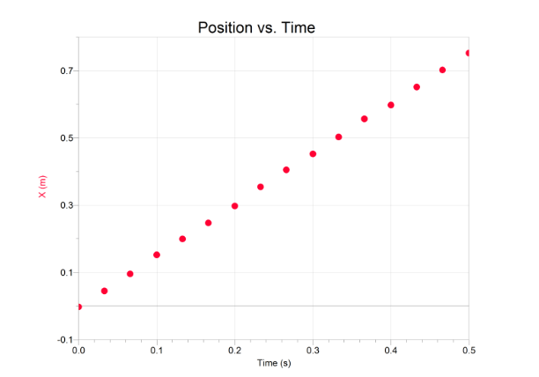

- Figure out a good way to find the speed of the ball in meters/second to three significant figures. Hint: Though other methods are acceptable; you might want to use the Linear Fit feature in the Logger Pro Analyze menu. Report your result and show or describe your method.

The speed of the ball in meter/second is 1.513 according to the Linear Fit function on Logger Pro. I obtained the value by adding up all the points of velocity and then dividing them by number of points I obtained.

1 - 2 Physics with Video Analysis

Reflections on Your Findings

- Comment on the nature of the motion and what evidence was most convincing in arriving at your conclusion.
The motion of the ball continuing at a constant speed is signified by the constant slope.

- How did your prediction in question 1(a) compare with your final conclusion?

My prediction was incorrect. It was assumed and believed that the ball would move slowly due to the friction acting on it. However, the analysis showed that the ball travelled at a constant linear speed

Physics with Video Analysis 1 - 3

